University of Missouri Kansas City

# Department of Computer Science and Electrical Engineering

## Advance Software Engineering

## Challenge-1

By

Siva Krishna Kommineni - 16104984

Ravisha Thallapalli - 16171645

1. **Design :** The challenge given is to develop a grocery store application with some features. For designing an application we need to first decide on the GUI that’s the graphical user interface and the database. We have designed a web based grocery store application using a sql data bse at the back end.

**Architecture Diagram:** Application diagram gives a view of how the system connects to the external sources like the services and the data sources. It gives a graphical view of how the application works with the help of them.

The architecture diagram below is being aligned in .NET Framework which makes use of several features like the Monitoring, hosting of ws and wcf services and persistence. This application also integrates the management services provided by the IIS and the tools of the IIS console which monitors them.



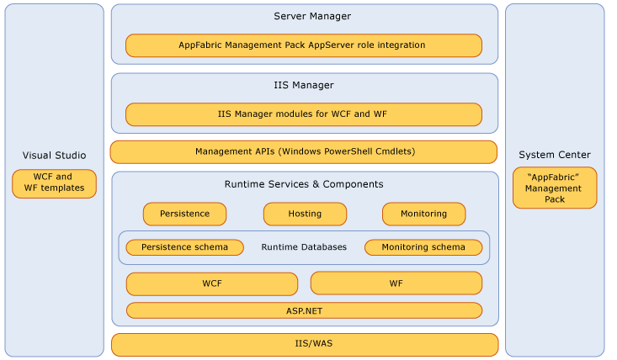

**Class Diagram**:Class diagram gives information about the classes, their methods and the attributes used and how these classes and their methods are related to each other. It is indeed a static structure diagram.

The grocery store application here developed has 7 classes called the grocery store menu, product details , Cart, Bar code scanner, Reach store and billing followed by the methods and their attributes as shown in the diagram below.



**Github Link:-**

<https://github.com/sk7x9/CS551-Challenge>

**Features Implemented:** The application developed here is the grocery store application which contains the following features:

It contains a variety of products available in a grocery store with their details such as product ID, Product Name, Product Price, Quantity available in the store etc.

With the information available we have implemented features for finding the product based on their product i.e. it searches the product either based on product Name

We have implemented other feature which is a search bar where the stores can be searched. For example if we search for Walmart we get the Walmart stores available nearby.

We have even implemented a search based on the bar code scanner where a camera reads the bar code and recognizes the produces which then displays the product and its related details associated with it. Like price, quantity, add to card.

We have tried to implement the reach store feature which gives user a way to reach the store. But there was some problem with map object which was not getting initialized.

Below are the screen shots of the application.

This screen shot is the home page of the application where a new user can create an account by clicking on the register link. Registered users can login to the application for more benefits of the services.

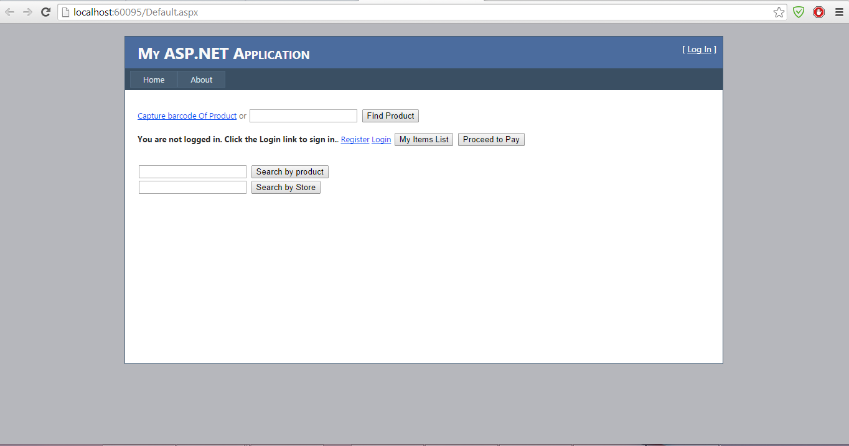

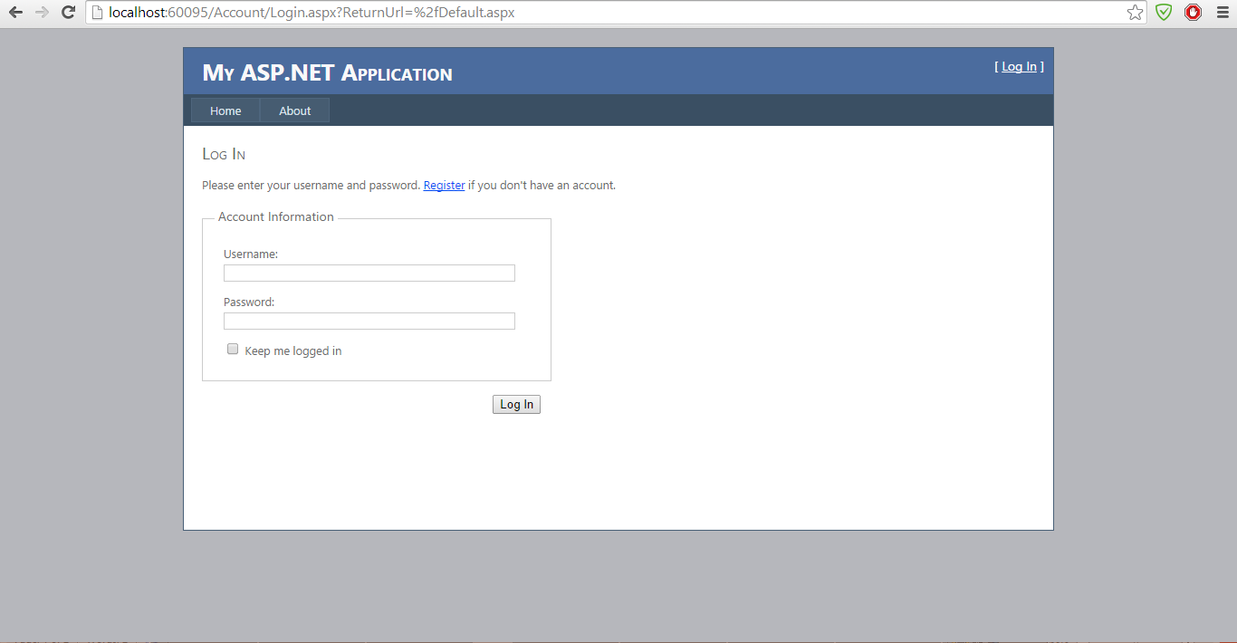

The below link is the registration link for the new users.

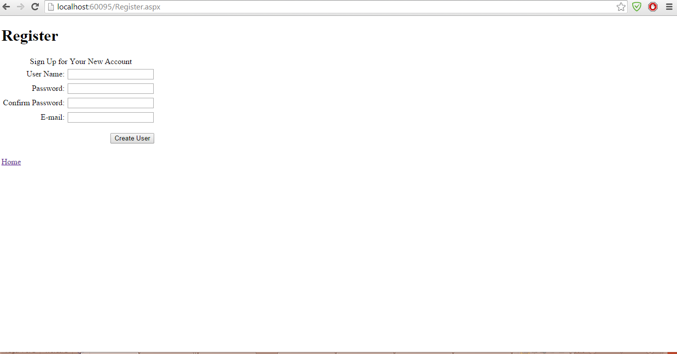

The below screen shot is the screen shot of the application.

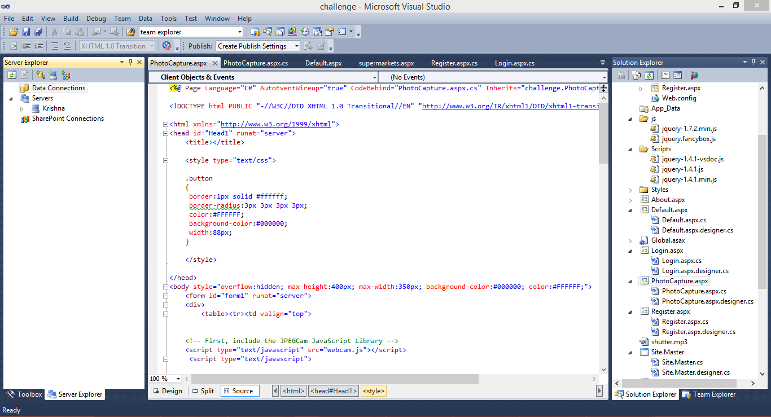

This below screen shot gives the search by product name.

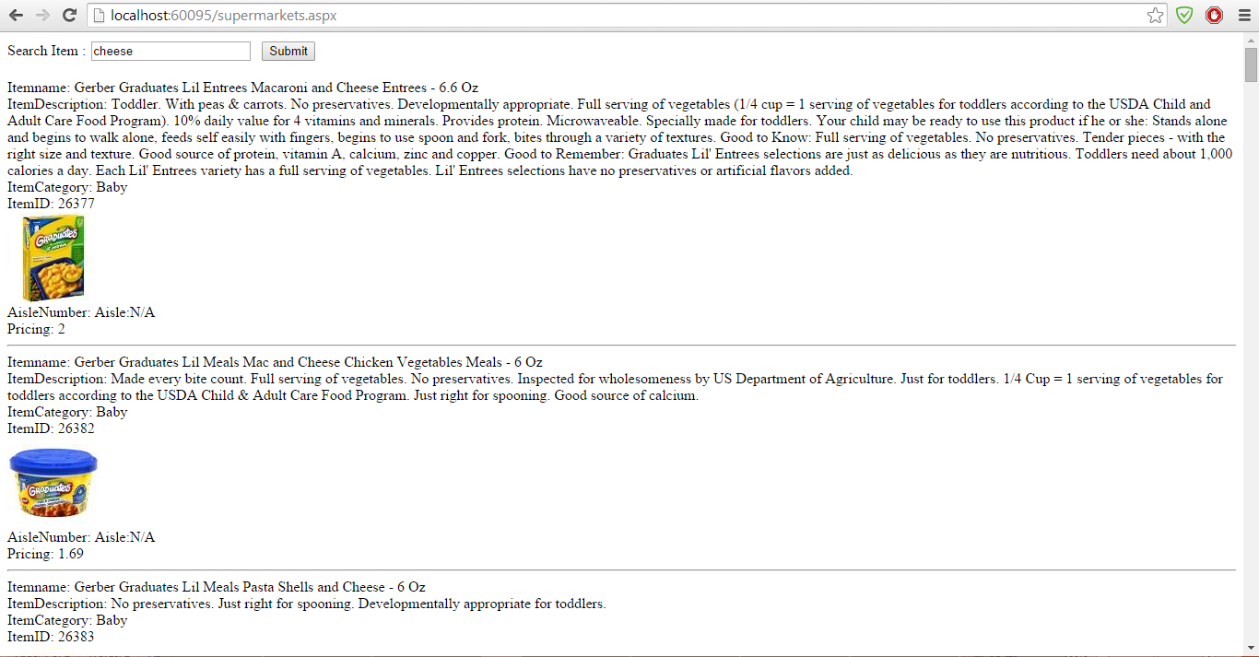

This screen shots gives the search by store name.

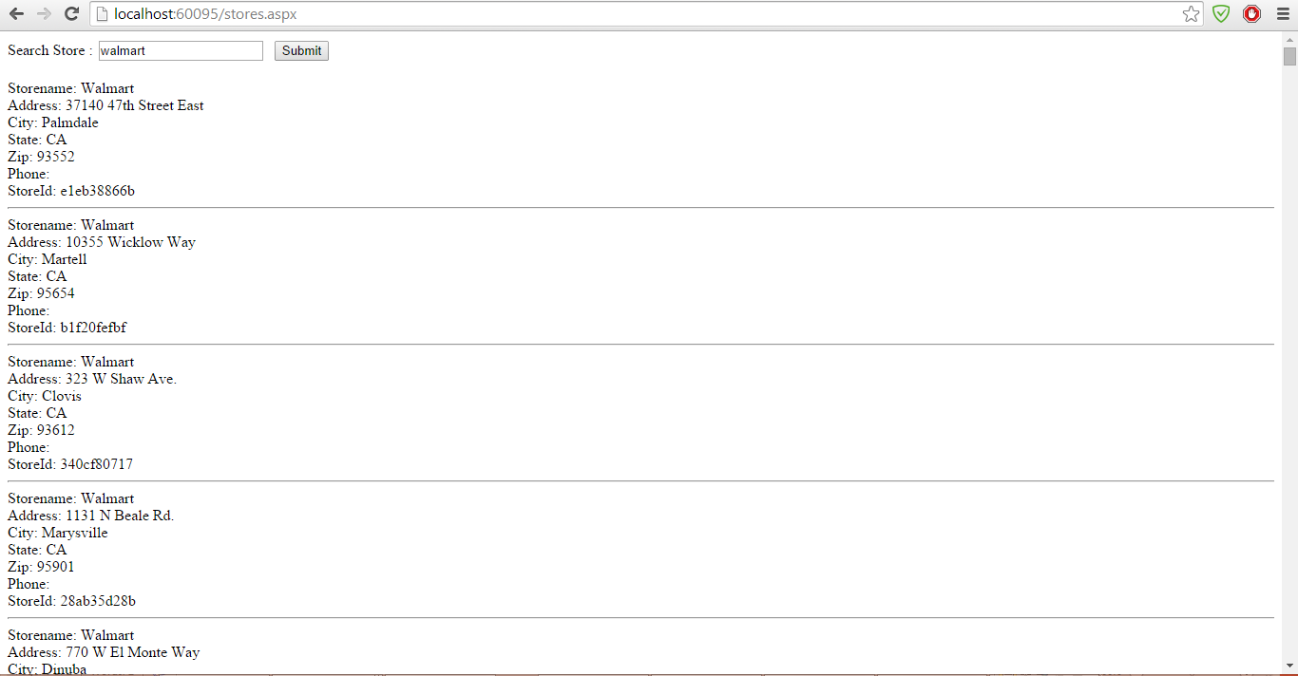

This screen shot gives the screen shot of the barcode where the camera scans the code of the product.

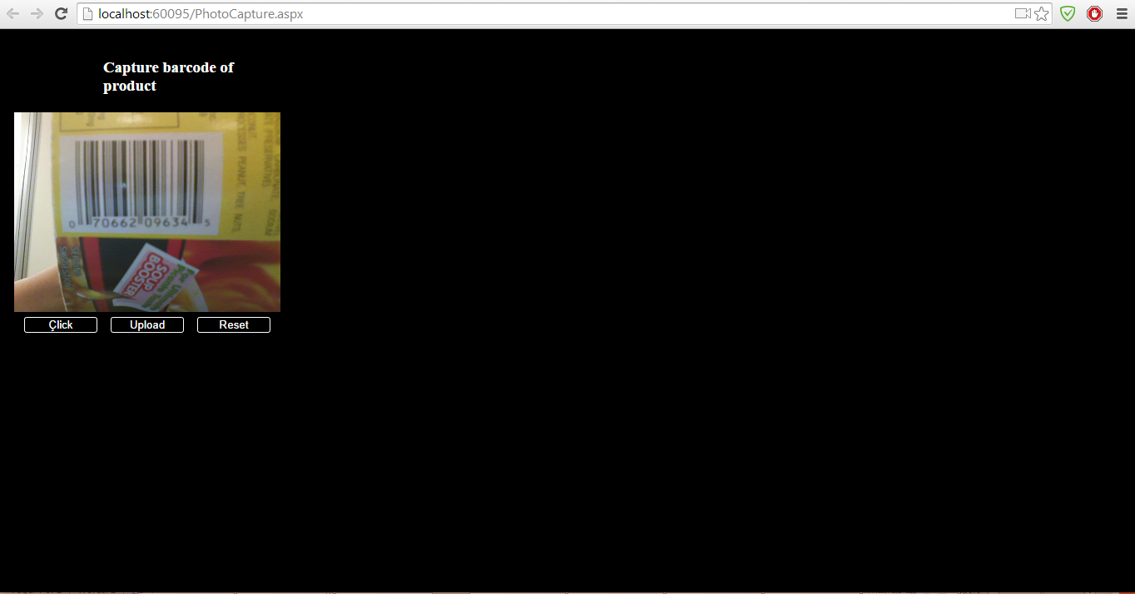

When the bar code of the product gets scanned the below screen will be displayed with the product details.

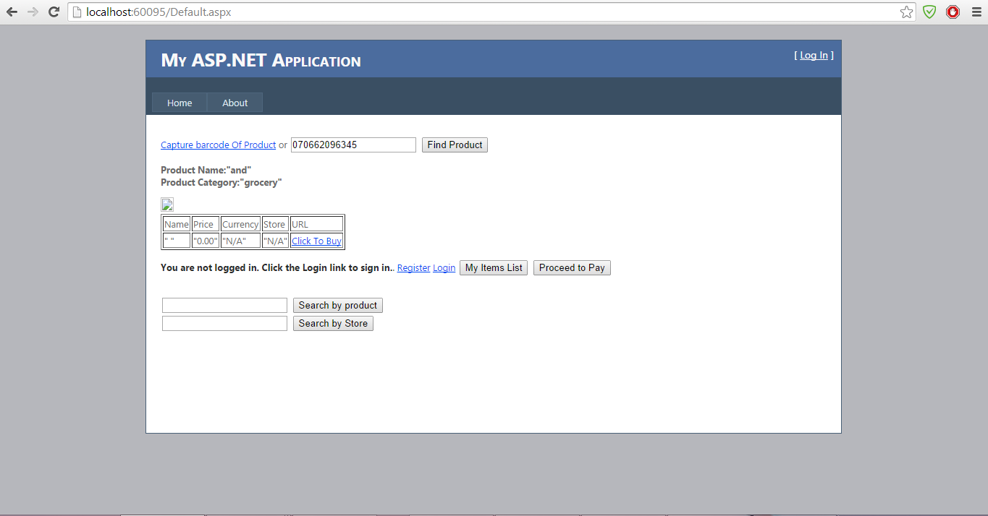

This is the screen shot of the map services to route user from their current location to the store location.

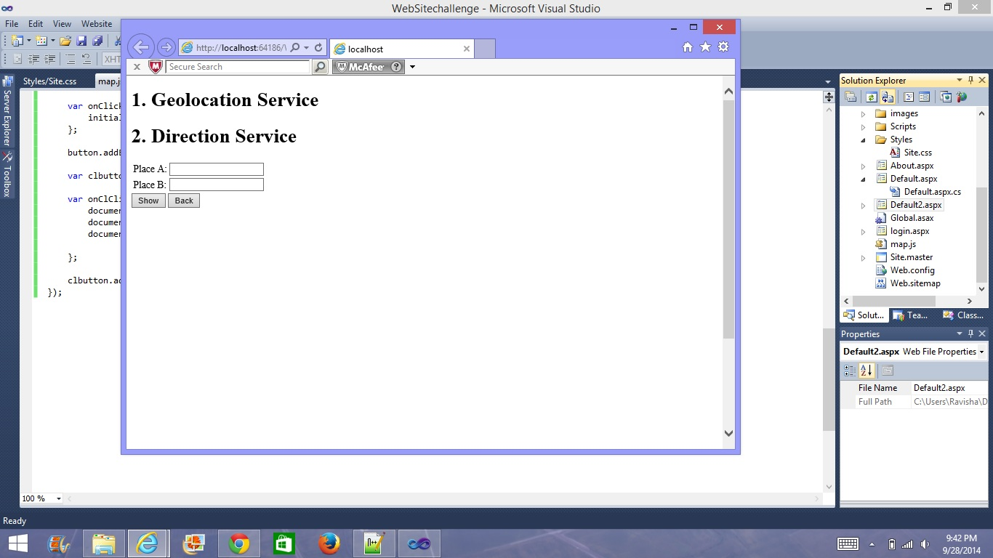

**Web Services:** We have used the bar code scanner APIs and the Google maps APIs in our application.

**Database**: We have used the SQL database in our application. Where we created the tables and given the details and stored the details of the products for the search.

**Mobile User Interface**: We have developed our web application in HTML5 and CSS which can be deployed in the emulator.

**Limitations:-** Facing problems with scanning Technology

**References:-**

Supermarket API

<http://www.supermarketapi.com/>

Amazon’s UPC/Product Database

<http://docs.aws.amazon.com/AWSECommerceService/latest/DG/EX_LookupbyUPC.html>

<http://msdn.microsoft.com/en-us/library/ee677255(v=azure.10).aspx>

[**https://github.com/vgz8b/GiftApp**](https://github.com/vgz8b/GiftApp)

[www.google.com](http://www.google.com)